**LIST OF EXPERIMENTS**

1. The lexical analyzer should ignore redundant spaces, tabs and new lines. It should also ignore comments. Although the syntax specification states that identifiers can be arbitrarily long, you may restrict the length to some reasonable value. Write a LEX specification file to take input C program from a .c file and count t he number of characters, number of lines & number of words.

# Input Source Program: (sample.c)

#include <stdio.h> int main()

{

int number1, number2, sum; printf("Enter two integers: "); scanf("%d %d", &number1, &number2); sum = number1 + number2; printf("%d + %d

= %d", number1, number2, sum); return 0;

}

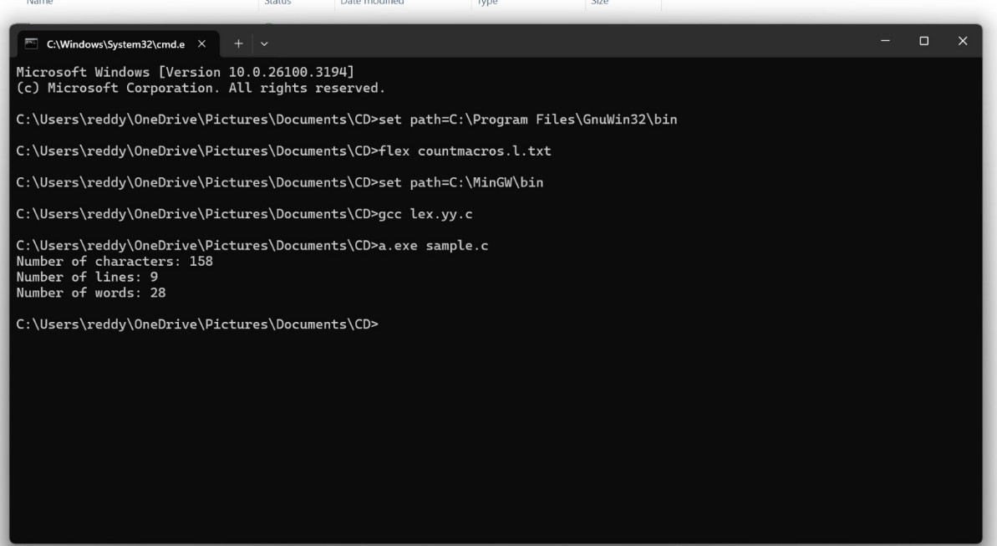

1. Write a LEX program to print all the constants in the given C source program file.

# Input Source Program: (sample.c)

#define PI 3.14 #include<stdio.h>

#include<conio.h> void main()

{

int a,b,c = 30; printf("hello");

}

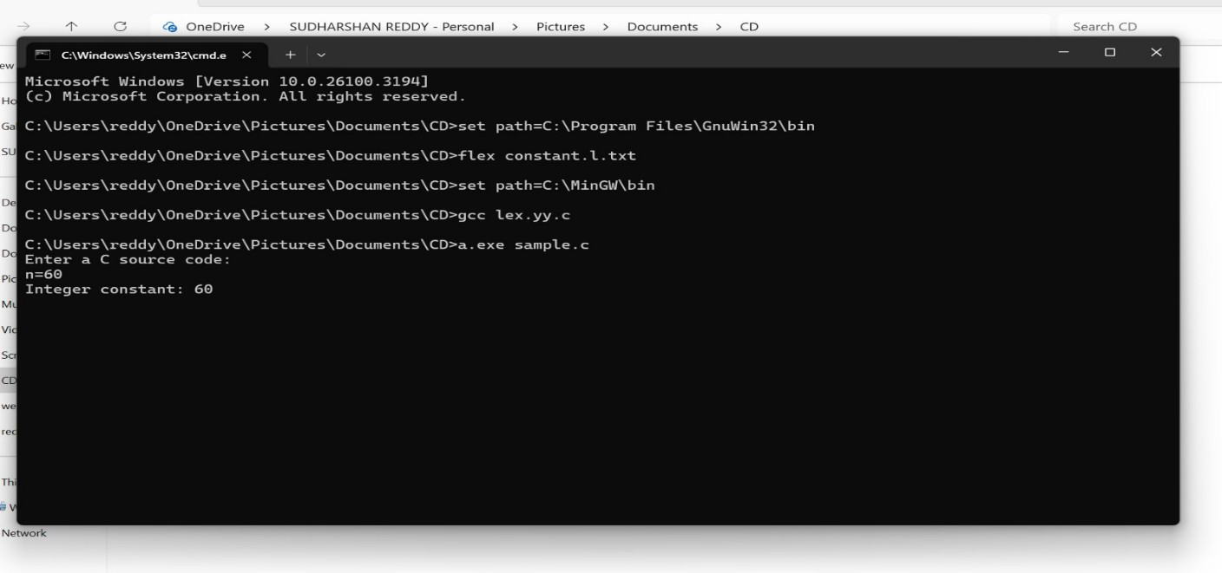

1. Write a LEX program to count the number of Macros defined and header files included in the C program.

# Input Source Program: (sample.c)

#define PI 3.14 #include<stdio.h> #include<conio.h> void main()

{ int a,b,c = 30;

printf("hello")

;

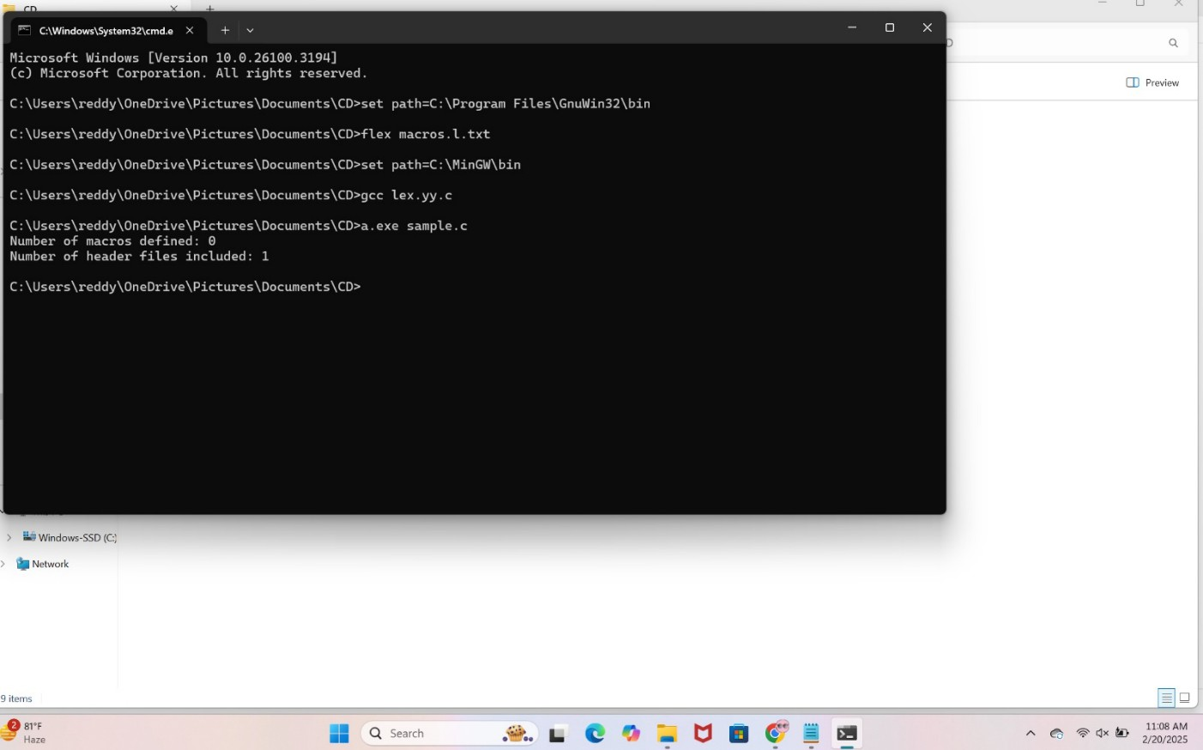}

1. Write a LEX program to print all HTML tags in the input file.

# Input Source Program: (sample.html)

<html>

<body>

<h1>My First Heading</h1>

<p>My first paragraph.</p>

</body> </html>

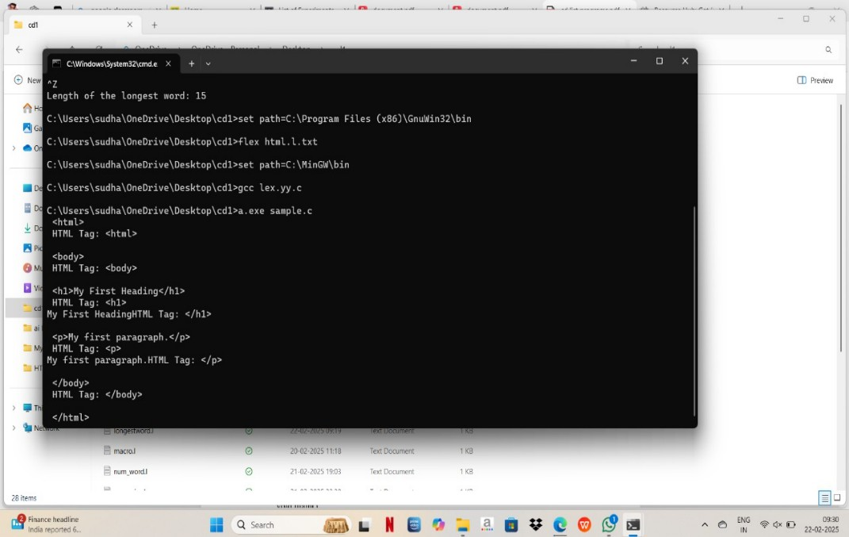 >

1. Write a LEX program which adds line numbers to the given C program file and display the same in the standard output.

# Input Source Program: (sample.c)

#define PI 3.14 #include<stdio.h> #include<conio.h> void main()

{ int a,b,c = 30;

printf("hello")

;

}

